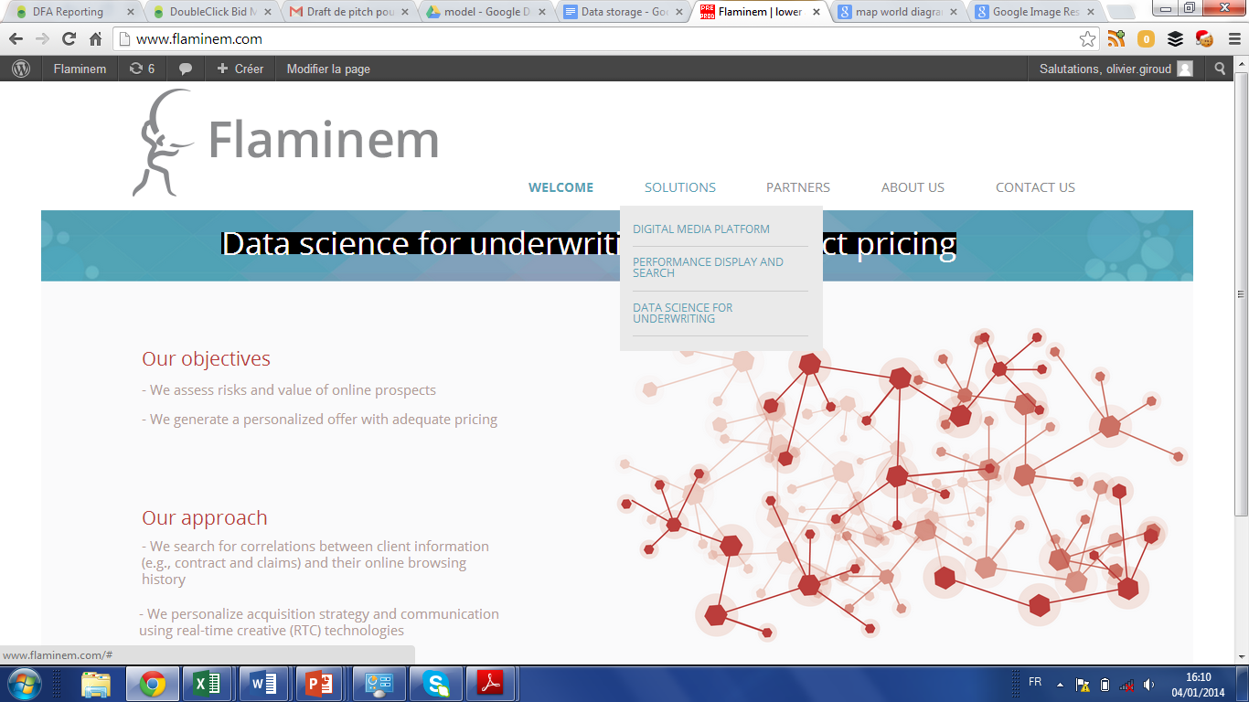



Re-inventing financial services with the power of data

***Who are we?***

Flaminem was founded in 2013 by **Thomas Serval**, ex- Microsoft and Director of Media & Platform Google SEEMEA, **Olivier Giroud**, ex-McKinsey along with a team of world-class mathematicians and developers

***What do we do?***

Flaminem helps **global insurers and retail banks** leverage and enrich **their data combined with online signals** to improve customer acquisition, cross-sell and anti-churn  
  
We predict investment decisions for individuals (e.g., car purchasing) by analyzing their browsing history and **help our clients optimize key lifecycle management value levers**

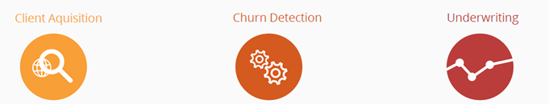**Client acquisition** 

We detect high-value intent users and engage them using RTB (Real-Time Bidding) technologies at the right moment in their decision journey

**We generate high-value leads and help select the best prospects**

**Cross-sell**

We provide a platform that ingests, cleanses and anonymizes client data (e.g., claims, contracts) and mixes with online signals to improve cross-sell score

**We help upsell our clients’ customers**

**Anti-churn**

We provide a platform that ingests, cleanses and anonymizes client data (e.g., claims, contracts) and mixes with online signals to detect **when** client would churn , understand **why**, and help decide **how** and **whether to retain clients based on their Lifetime value**

**We help retain our clients’ best customers**

<\br>

***Why Flaminem is called Flaminem ?***

Flaminem is the accusative form of flamen. A flamen is a priest devoted to the service of some gods, who turns on the flame. He would foresee the future.

***Contact us?***

Contact(at)flaminem(dot)com

**Privacy policy**